**SINGLE LAYER NEURAL NETWORK : ADAPTIVE LINEAR NEURON**

In this tutorial, We'll approach classification via historical **Perceptron** learning algorithm based on "Python Machine Learning by Sebastian Raschka, 2015".

We'll extract two features of two flowers form Iris data sets. Then, we'll updates weights using the difference between predicted and target values.

Although the Perceptron classified the two Iris flower classes perfectly, **convergence** is one of the biggest problems of the perceptron.

**Code : Perceptron learning algorithm**

The following code defines perceptron interface as a Python Class:

# perceptron.py

import numpy as np

class Perceptron(object):

def __init__(self, rate = 0.01, niter = 10):

self.rate = rate

self.niter = niter

def fit(self, X, y):

"""Fit training data

X : Training vectors, X.shape : [#samples, #features]

y : Target values, y.shape : [#samples]

"""

# weights

self.weight = np.zeros(1 + X.shape[1])

# Number of misclassifications

self.errors = [] # Number of misclassifications

for i in range(self.niter):

err = 0

for xi, target in zip(X, y):

delta_w = self.rate * (target - self.predict(xi))

self.weight[1:] += delta_w * xi

self.weight[0] += delta_w

err += int(delta_w != 0.0)

self.errors.append(err)

return self

def net_input(self, X):

"""Calculate net input"""

return np.dot(X, self.weight[1:]) + self.weight[0]

def predict(self, X):

"""Return class label after unit step"""

return np.where(self.net_input(X) >= 0.0, 1, -1)

**Preprocessing Iris data set**

To test our perceptron implementation, we will load the two flower classes *Setosa* and *Versicolor* from the Iris data set. The perceptron rule is not restricted to two dimensions, however, we will only consider the two features *sepal length* and *petal length* for visualization purposes.

Now, we will use the **pandas** library to load the Iris data set into a **DataFrame** object:

>>> import pandas as pd

>>> df = pd.read_csv('https://archive.ics.uci.edu/ml/machine-learning-databases/iris/iris.data', header=None)

>>>

>>> df.tail()

0 1 2 3 4

145 6.7 3.0 5.2 2.3 Iris-virginica

146 6.3 2.5 5.0 1.9 Iris-virginica

147 6.5 3.0 5.2 2.0 Iris-virginica

148 6.2 3.4 5.4 2.3 Iris-virginica

149 5.9 3.0 5.1 1.8 Iris-virginica

>>>

>>> df.iloc[145:150, 0:5]

0 1 2 3 4

145 6.7 3.0 5.2 2.3 Iris-virginica

146 6.3 2.5 5.0 1.9 Iris-virginica

147 6.5 3.0 5.2 2.0 Iris-virginica

148 6.2 3.4 5.4 2.3 Iris-virginica

149 5.9 3.0 5.1 1.8 Iris-virginica

Next, we extract the first 100 class labels that correspond to the 50 *Iris-Setosa* and 50 *Iris-Versicolor* flowers, respectively:

>>> import matplotlib.pyplot as plt

>>> import numpy as np

>>>

>>> y = df.iloc[0:100, 4].values

>>> y

array(['Iris-setosa', 'Iris-setosa', 'Iris-setosa', 'Iris-setosa',

'Iris-setosa', 'Iris-setosa', 'Iris-setosa', 'Iris-setosa',

'Iris-setosa', 'Iris-setosa', 'Iris-setosa', 'Iris-setosa',

'Iris-setosa', 'Iris-setosa', 'Iris-setosa', 'Iris-setosa',

'Iris-setosa', 'Iris-setosa', 'Iris-setosa', 'Iris-setosa',

'Iris-setosa', 'Iris-setosa', 'Iris-setosa', 'Iris-setosa',

'Iris-setosa', 'Iris-setosa', 'Iris-setosa', 'Iris-setosa',

'Iris-setosa', 'Iris-setosa', 'Iris-setosa', 'Iris-setosa',

'Iris-setosa', 'Iris-setosa', 'Iris-setosa', 'Iris-setosa',

'Iris-setosa', 'Iris-setosa', 'Iris-setosa', 'Iris-setosa',

'Iris-setosa', 'Iris-setosa', 'Iris-setosa', 'Iris-setosa',

'Iris-setosa', 'Iris-setosa', 'Iris-setosa', 'Iris-setosa',

'Iris-setosa', 'Iris-setosa', 'Iris-versicolor', 'Iris-versicolor',

'Iris-versicolor', 'Iris-versicolor', 'Iris-versicolor',

'Iris-versicolor', 'Iris-versicolor', 'Iris-versicolor',

'Iris-versicolor', 'Iris-versicolor', 'Iris-versicolor',

'Iris-versicolor', 'Iris-versicolor', 'Iris-versicolor',

'Iris-versicolor', 'Iris-versicolor', 'Iris-versicolor',

'Iris-versicolor', 'Iris-versicolor', 'Iris-versicolor',

'Iris-versicolor', 'Iris-versicolor', 'Iris-versicolor',

'Iris-versicolor', 'Iris-versicolor', 'Iris-versicolor',

'Iris-versicolor', 'Iris-versicolor', 'Iris-versicolor',

'Iris-versicolor', 'Iris-versicolor', 'Iris-versicolor',

'Iris-versicolor', 'Iris-versicolor', 'Iris-versicolor',

'Iris-versicolor', 'Iris-versicolor', 'Iris-versicolor',

'Iris-versicolor', 'Iris-versicolor', 'Iris-versicolor',

'Iris-versicolor', 'Iris-versicolor', 'Iris-versicolor',

'Iris-versicolor', 'Iris-versicolor', 'Iris-versicolor',

'Iris-versicolor', 'Iris-versicolor', 'Iris-versicolor'], dtype=object)

>>>

The we want to convert the class labels into the two integer class labels 1 (Versicolor) and -1 (Setosa) that we assign to a vector **y** where the values method of a pandas DataFrame yields the corresponding NumPy representation.

>>> y = np.where(y == 'Iris-setosa', -1, 1)

>>> y

array([-1, -1, -1, -1, -1, -1, -1, -1, -1, -1, -1, -1, -1, -1, -1, -1, -1,

-1, -1, -1, -1, -1, -1, -1, -1, -1, -1, -1, -1, -1, -1, -1, -1, -1,

-1, -1, -1, -1, -1, -1, -1, -1, -1, -1, -1, -1, -1, -1, -1, -1, 1,

1, 1, 1, 1, 1, 1, 1, 1, 1, 1, 1, 1, 1, 1, 1, 1, 1,

1, 1, 1, 1, 1, 1, 1, 1, 1, 1, 1, 1, 1, 1, 1, 1, 1,

1, 1, 1, 1, 1, 1, 1, 1, 1, 1, 1, 1, 1, 1, 1])

Also, we need to extract the first feature column (sepal length) and the third feature column (petal length) of those 100 training samples and assign them to a feature matrix **X**:

>>> X = df.iloc[0:100, [0, 2]].values

>>> X

array([[ 5.1, 1.4],

[ 4.9, 1.4],

...

[ 5.1, 3. ],

[ 5.7, 4.1]])

>>>

We can visualize via a two-dimensional scatter plot using the matplotlib:

>>> plt.scatter(X[:50, 0], X[:50, 1], color='red', marker='o', label='setosa')

>>> plt.scatter(X[50:100, 0], X[50:100, 1], color='blue', marker='x', label='versicolor')

>>> plt.xlabel('petal length')

>>> plt.ylabel('sepal length')

>>> plt.legend(loc='upper left')

>>> plt.show()

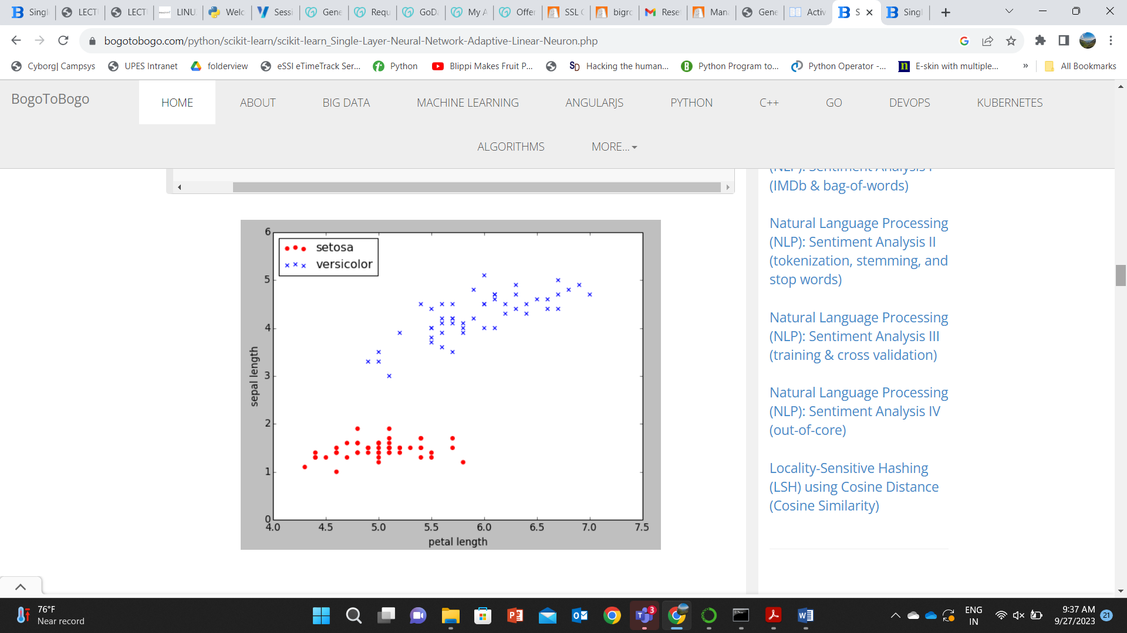

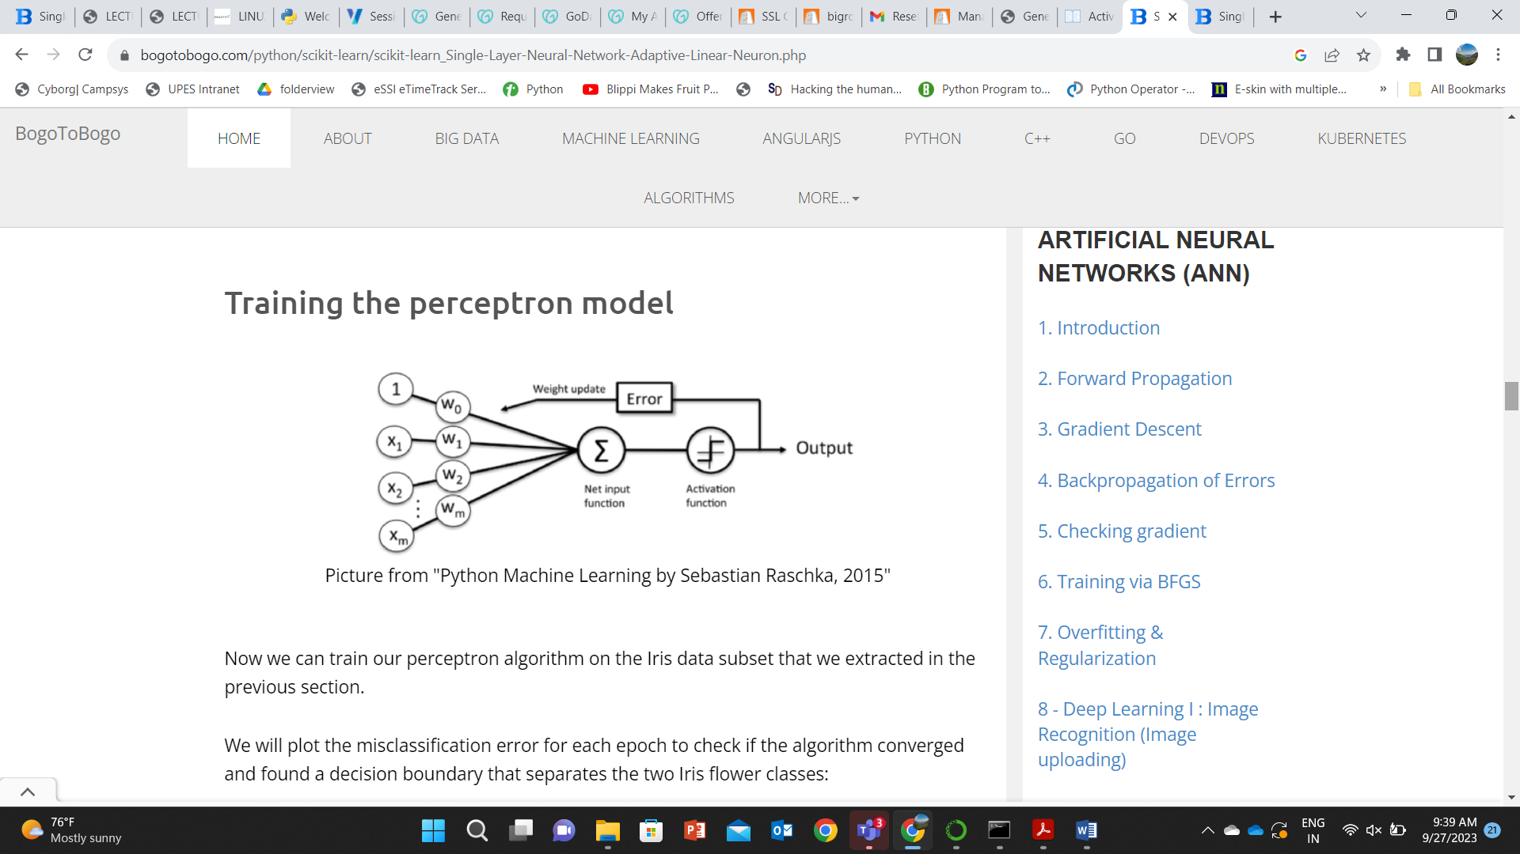

Now we can train our perceptron algorithm on the Iris data subset that we extracted in the previous section.

We will plot the misclassification error for each epoch to check if the algorithm converged and found a decision boundary that separates the two Iris flower classes:

>>> # import Perceptron from perceptron.py

>>> from perceptron import Perceptron

>>> pn = Perceptron(0.1, 10)

>>> pn.fit(X, y)

>>> plt.plot(range(1, len(pn.errors) + 1), pn.errors, marker='o')

>>> plt.xlabel('Epochs')

>>> plt.ylabel('Number of misclassifications')

>>> plt.show()

We can see the plot of the misclassification errors versus the number of epochs as shown below:

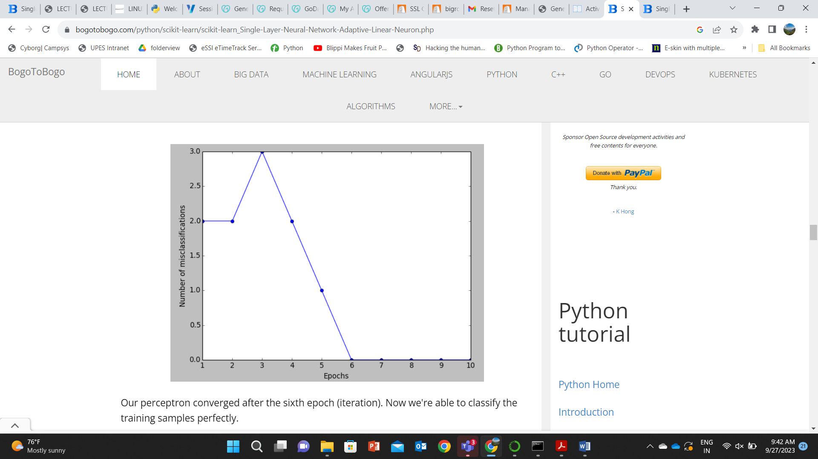

Our perceptron converged after the sixth epoch (iteration). Now we're able to classify the training samples perfectly.

**Visualize the decision boundaries**

To visualize the decision boundaries for our 2D datasets, let's implement a small convenience function:

from matplotlib.colors import ListedColormap

def plot_decision_regions(X, y, classifier, resolution=0.02):

# setup marker generator and color map

markers = ('s', 'x', 'o', '^', 'v')

colors = ('red', 'blue', 'lightgreen', 'gray', 'cyan')

cmap = ListedColormap(colors[:len(np.unique(y))])

# plot the decision surface

x1_min, x1_max = X[:, 0].min() - 1, X[:, 0].max() + 1

x2_min, x2_max = X[:, 1].min() - 1, X[:, 1].max() + 1

xx1, xx2 = np.meshgrid(np.arange(x1_min, x1_max, resolution),

np.arange(x2_min, x2_max, resolution))

Z = classifier.predict(np.array([xx1.ravel(), xx2.ravel()]).T)

Z = Z.reshape(xx1.shape)

plt.contourf(xx1, xx2, Z, alpha=0.4, cmap=cmap)

plt.xlim(xx1.min(), xx1.max())

plt.ylim(xx2.min(), xx2.max())

# plot class samples

for idx, cl in enumerate(np.unique(y)):

plt.scatter(x=X[y == cl, 0], y=X[y == cl, 1],

alpha=0.8, c=cmap(idx),

marker=markers[idx], label=cl)

In the code above, we define a number of colors and markers and create a color map from the list of colors via ListedColormap.

Then, we determine the minimum and maximum values for the two features and use those feature vectors to create a pair of grid arrays xx1 and xx2 via the NumPy meshgrid function.

Since we trained our perceptron classifier on two feature dimensions, we need to flatten the grid arrays and create a matrix that has the same number of columns as the Iris training subset so that we can use the predict method to predict the class labels Z of the corresponding grid points.

After reshaping the predicted class labels Z into a grid with the same dimensions as xx1 and xx2 , we can now draw a contour plot via matplotlib's contourf function that maps the different decision regions to different colors for each predicted class in the grid array:

>>> plot_decision_regions(X, y, classifier=pn)

>>> plt.xlabel('sepal length [cm]')

>>> plt.ylabel('petal length [cm]')

>>> plt.legend(loc='upper left')

>>> plt.show()

As shown in the following figure, we can now see a plot of the decision regions.

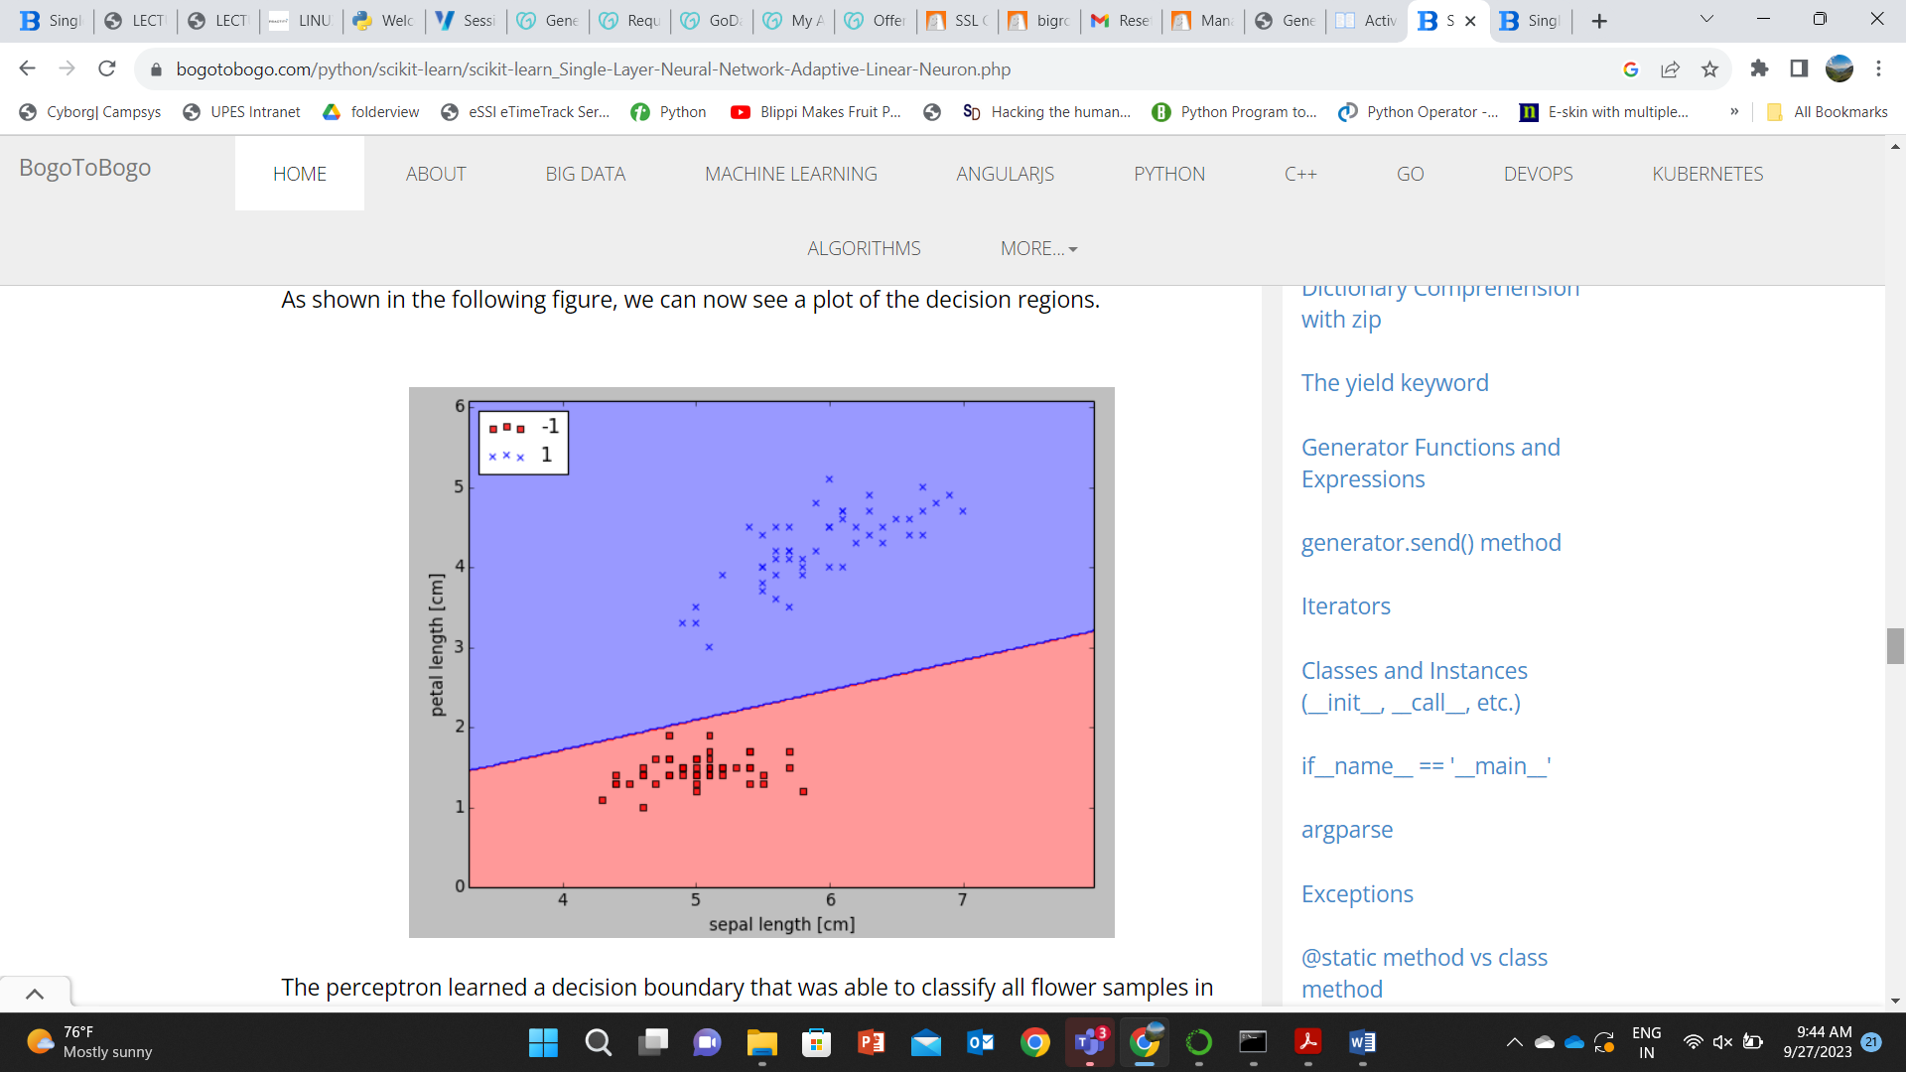

The perceptron learned a decision boundary that was able to classify all flower samples in the Iris training subset perfectly.

Although the perceptron classified the two Iris flower classes perfectly, **convergence** is one of the biggest problems of the perceptron.

Frank Rosenblatt proved mathematically that the perceptron learning rule converges if the two classes can be separated by a **linear** hyperplane.

However, if classes cannot be separated perfectly by such a linear decision boundary, the weights will never stop updating unless we set a maximum number of epochs.